**Practice Project**

Validation of User login

Output:

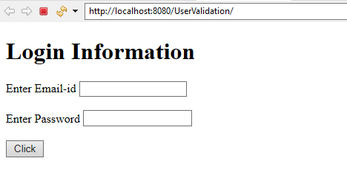

Entered the correct id and password

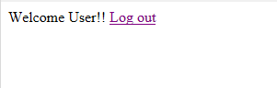

Clicked logout

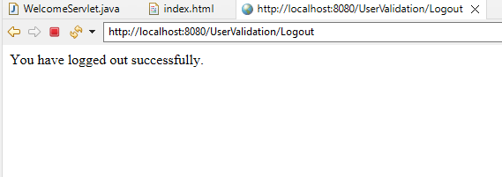

When entering incorrect id or password

